UNIT 7 HOME AND BUILDINGS
OUTLINE

1 Language Development
1.1 should
1.2 Grammar for writing:
- Comparing qualities
- Comparative adjectives
- Joining sentences with but
2 Vocabulary
2.1 Vocabulary for rooms
2.2 Adjectives for furniture
(e.g. comfortable, _________, _________ )
2.3 Vocabulary for buildings
(e.g. library, _________, _________ )
2.4 Vocabulary for parts of buildings
(e.g. exit, _________, _________ )
2.5 Adjective to describe buildings
(e.g. modern, _________, _________ )
3 Critical thinking
3.1 Find reasons for and against
3.2 Compare data
4 Input
4.1 Listening
4.1.1 Listening for reasons
4.1.2 Understanding key vocabulary
4.1.3 Listening for main ideas
4.1.4 Listening for detail
4.2 Reading
4.2.1 Using visuals to predict content
4.2.2 Understanding key vocabulary
4.2.3 Scanning to find information
4.2.4 Reading for detail
4.2.5 Previewing
4.2.6 Understanding discourse
5 Output
5.1 Speaking task:
Discuss ideas for a new building
5.2 Academic writing skills:
Spelling: double consonants
5.3 Writing task:
Write a comparison of two buildings

EXERCISES
- Match the opinions with the correct reasons. There are two extra reasons.
Then listen to check.
- The kitchen should not be red __e_
- The kitchen walls should be white _f__
3）The bedroom walls should not be white _b__
4）The bedroom walls should be blue __g_
5）The big bookcase should go in the living room _c__

- because it’s a beautiful colour.
- because you’re going to wake up early when it’s sunny.
- because the bedroom is small.
- because the bedroom is big.
- because it’s a strong colour.
- because it’s better when it’s sunny.
- because it can help you sleep.

2 Find the words for furniture, homes and buildings in the matrix（矩阵）below.
1) cheap 2) clean 3) comfortable 4) dirty 5) expensive
6) leather 7) metal 8) narrow 9) noisy 10) plastic
11) quiet 12) wooden

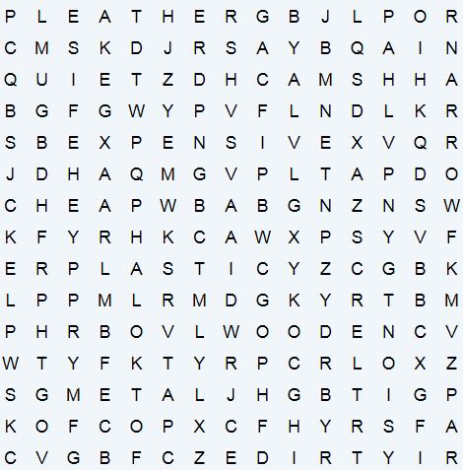

3 Reading comprehension.
Aït Benhaddou
What is Aït Benhaddou?
Aït Benhaddou is a fortified village in Morocco. It is in the High Atlas Mountains next to the Ounila River. There is a high wall around the village and there are towers at the corners of the wall. Inside the wall, there are many buildings close together. The wall and the buildings are made from earth. People have to repair the earth buildings regularly because rain damages them.
Who built Aït Benhaddou?
The Berber tribes of North Africa built Aït Benhaddou. They built many towns and villages in the Atlas Mountains. There are over 1,000 villages in the area. Some families still live in the old village of Aït Benhaddou. Most people now live in a newer village on the other side of the river.
Why is Aït Benhaddou famous?
Aït Benhaddou is a very good example of southern Moroccan architecture. Most of the buildings inside the wall are houses. Some are simple but some look like small castles. There is also a mosque, a public square and a caravanserai. Aït Benhaddou is on the old trade route from Sudan to Marrakesh. Groups of travellers stayed in the caravanserai. Aït Benhaddou became a UNESCO World Heritage Site in 1987. The village appears in many films. Scenes from The Mummy (1999), Gladiator (2000) and Prince of Persia (2010) are set here. Many tourists come to visit Aït Benhaddou.
- Read the text. Write true (T) or false (F) next to the statements.
- Aït Benhaddou is next to the Ounila River in the High Atlas Mountains. ___
- There are towers and a wall around Aït Benhaddou. ___
- The houses in Aït Benhaddou are made from wood. ___
- The Berber people built Aït Benhaddou. ___
- There are many Berber villages in the mountains. ___
- Today, the houses of Aït Benhaddou are empty. ___
- The houses are very strong. ___
- The houses are very unusual in this part of Morocco. ___
- Aït Benhaddou is a popular place for film companies. ___
- Many people visit Aït Benhaddou. ___

- Write the words from the box in the gaps. You do not need every word.
cinema ice rink Library Museum Hotel disco school shopping mall Stadium train station
swimming pool hospital supermarket sports club

- There are 147 luxury guest rooms at the ____________ de Crillon in Paris.
- You can watch new films at the ____________ .
- My sister is a doctor at the new ____________ .
- You usually play ice hockey at an ____________ .
- There are over 252 shops in the Westfield ____________ in London.
- 85,454 people can watch Real Madrid play football in Santiago Bernabeu ____________ .
- There are over 14 million books in the British ____________ in London.
- Grand Central Terminal in New York is the largest ____________ in the world, with 44 platforms.
- The State Hermitage ____________ in Saint Petersburg has over 3 million pieces of art.
- Crystal Lagoon at San Alfonso del Mar resort, Chile, is 1 km long and up to 35 m deep. It is the largest ____________ in the world.
5 Writing task: write a comparison of two buildings.
- Choose two shopping malls from Table 7.1 in the Critical Thinking section.

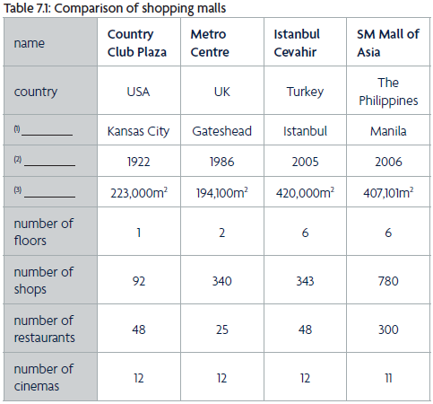
location
year
size

- Write sentences on the topics below.
1 Write the names of your malls.
2 Write the location of your malls.
3 Compare the age of your malls.
4 Compare the size of your malls.
5 Compare the number of floors in your malls.
6 Compare the number of shops in your malls.
7 Compare the number of restaurants in your malls.
8 Compare the number of cinemas in your malls.

3）Use the task checklist to review your sentences.
TASK CHECKLIST | ✔
Did you compare two malls?
Do your sentences have than after a comparative adjective?
Do your comparative adjectives with one or two syllables end
-(e)r?
Do your comparative adjectives with one syllable that end in a
vowel + a consonant have double consonants?
Do your comparative adjectives with two syllables have more +
adjective + than?
Do your sentences which compare quantities have a subject and
verb + more + a noun or a noun phrase + than?

- Speaking task:
Speak out your ideas for a new restaurant.
You should say:
Your choices of the place, the kind of food, the name of the restaurant, and the design for it.
Record your task response and upload it to the homework zone in time.

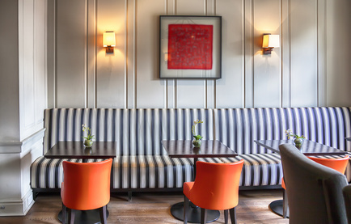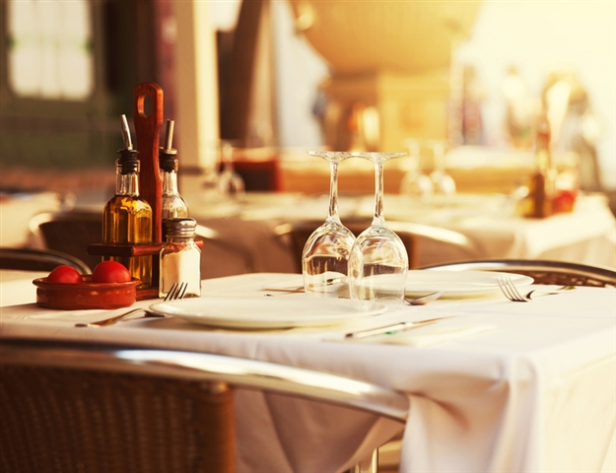
KEYS
- 1) – 5) e, f, b, g, c.
- Find the answers in the shadow (用阴影标注的单词即为答案).
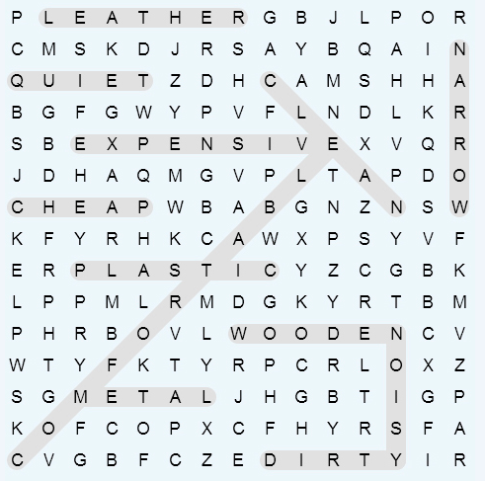

- 1-5 TTFTT 6-10 FFFTT
- 1-5 Hotel, cinema, hospital, ice rink, shopping mall;
6-10 Stadium, Library, train station, Museum, swimming pool.
5 – 6 As subjective tasks, there are no suggested answers for them.

Appendix: Worksheet for the speaking class.

以下是听说直播课的部分讲义，建议你提前预习，做好听课准备。
Speaking task: Discuss ideas for a new building
- Tell us about your ideas for a new restaurant.
When listening to the speaker, you should take notes in the table below.

 | Student's name  ______ | ______ | ______ | ______
Place
Food
Name
Design

